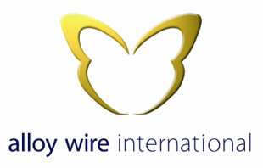

Business Ethics

Alloy Wire International has high ethical standards that are key to its business and endeavours to treat all customers, suppliers, sub-contractors, business partners and employees ethically in all interactions. This policy serves to ensure that all employees irrespective of their individual role within the company are aware of their collective and individual responsibilities with regards to business ethics.

Alloy Wire international is committed to protecting its employees, business partners and suppliers from any illegal or damaging actions by any representative of Alloy Wire International, either knowingly or unknowingly.

Alloy Wire International is committed to the following values:

- Integrity – To set and lead by example
- Reliability – Keeping its promises to its employees and business partners and abiding to any deadlines.
- Honesty – Communicating any issues to all relevant parties.
- Respect – Treating all with dignity, tolerance and courtesy while respecting privacy. (see human rights policy)
- Duty of Care – Taking great care not to harm others by respecting the Environment and following Health & Safety guidelines.
- Fairness – To treat all individuals and relevant business partners fairly and refrain from competing unfairly with others.
- Reputation – To build our professional reputation on the merits of all the above.

Alloy Wire International will not tolerate any breach of its ethical code, and will take the appropriate measures, including disciplinary action when and where it deems necessary.

This policy along with all other company policies will be subjected to an annual review to ensure that it remains relevant with regards to changing moral or social attitudes and Alloy Wire International will always endeavour to work to the best business practice.

Signed;

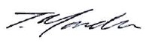
Tom Mander
Managing Director
27th January 2023

