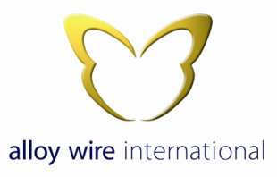
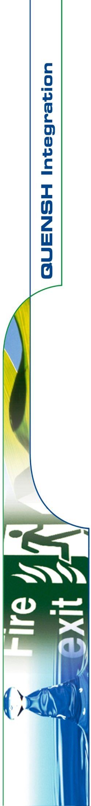

Anti-Bribery

Bribery is defined as the act of offering, giving, promising, asking, agreeing, receiving, accepting or soliciting something of value or of an advantage to influence an outcome either action or decision.

This anti-bribery policy applies to all Alloy Wire International employees irrespective of their individual role within the company.

Alloy Wire International is committed to conducting business in an honest and ethical manner and ensuring that all forms of bribery are prevented.

Alloy Wire International has a zero-tolerance stance against all forms of bribery and all business dealings and relationships will be dealt with fairly with integrity in a professional manner.

Alloy Wire International is bound by UK laws* with regard to our business conduct both on UK shores and abroad.

Gifts & Hospitality

Alloy Wire International will accept gestures of hospitality and goodwill (whether giving or receiving) so long as it meets the following requirements:

- It is not made with the intention of influencing a desired business advantage or exchange for any future favours or benefits.
- It is in compliance with UK laws*.
- It is appropriate for the circumstances (e.g. giving small gifts around Christmas or as a small thank you to a 3rd party for their contribution to a specific order).
- It is an appropriate gift given at the appropriate time when taking into account the reason for the gift.
- It is given / received openly and not in secret.
- Where it is inappropriate to decline the offer of a gift (i.e. when meeting with an individual of a certain religion / culture who may take offence).

Alloy Wire International recognises that different countries, regions, cultures and religions may have differing policies when it comes to gifts and hospitality so definitions of what is and is not acceptable will inevitably differ for each.

Charitable Donations

Alloy Wire International actively encourages the act of donating to charities and agrees to disclose all charitable contributions it makes.
However Alloy Wire International will ensure that all charitable donations made are legal under UK law* and are not used to facilitate or conceal any act of bribery.

* Language deemed would be English for all parties

Signed;

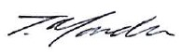
Tom Mander
Managing Director
27th January 2023

