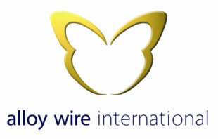
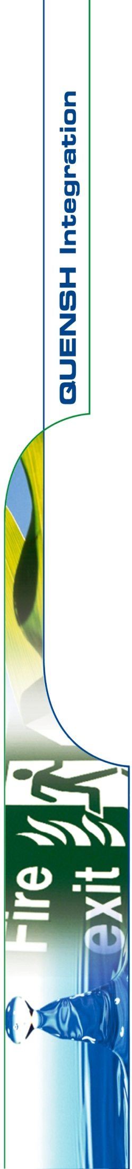

HEALTH & SAFETY POLICY STATEMENT

Management of Alloy Wire International regards the promotion of and continual improvement of Health and Safety performance as a mutual objective for Management and employees at all levels.

Alloy Wire International are committed to at least complying with all applicable legal and other requirements to which we subscribe.

It is the declared company policy to do all that is reasonably practicable to prevent personal injury and ill health, damage to property and to protect everyone from foreseeable work hazards within the Company’s control, including the public in so far as they come into contact with our activities.

It is the policy of the company, where it is reasonably practicable to:
- Provide plant, equipment and systems of work that are safe and without risk to health.
- Provide for the safe handling and transport of product, materials and equipment.
- Provide comprehensive information, instruction, training and supervision, ensuring in so far as is reasonably practicable, the Health, Safety and Welfare of every employee.
- To maintain, so far as is reasonably practicable, a safe and risk free workplace and provide safe means of access to and egress from all workplace areas.
- Provide and maintain a safe and healthy working environment with adequate welfare facilities.

All employees are encouraged to contribute towards making work areas as safe as possible by continually appraising working practices and ensuring that the safest possible methods are adopted.

Employees also have a duty to co-operate in this objective:
- By working safely and efficiently.
- By using any equipment provided in a safe and efficient manner.
- By reporting any incidents or near misses that have led or may lead to injury or damage.
- By adhering to safe working practices / procedures to secure a safe place of work.
- By assisting in the investigation of accidents, incidents and near misses.
- By taking a positive attitude to accident prevention, being vigilant at all times to prevent any mishaps however trivial and bringing them to the attention of the management.

Alloy Wire International will comply with Health & Safety laws, regulations and other requirements relevant to our business. We will provide adequate resources and closely monitor our business administration, production, packing and despatch processes to ensure that the company’s operations and opportunities are effectively managed and risks mitigated in accordance with the requirements of BS EN 9100, BS EN ISO 9001, BS EN ISO 14001, BS EN ISO 45001 and BS EN ISO 13485.

This policy will be communicated to all staff and any necessary stakeholders and interested parties i.e. sub-contractors that may be working on our behalf, and will be available to the public via Alloy Wire International web site: www.alloywire.com

The Directors will review this policy and formulate QUENSH objectives during annual management reviews to ensure its integrity, effectiveness and compatibility with the context and strategic direction of the organisation.
Signed:

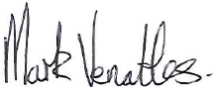

Mark Venables
Managing Director
19th January 2022

